CHAPTER 4: SYSTEM DESIGN
4.1 Basic Modules
The AI-Rescue platform is divided into functional modules. Each module is responsible for a specific set of operations while communicating with other modules through the application's backend.
4.1.1 User Authentication and Role Management
This module manages user registration, login, authentication, and role-based access.
Main functions:
- User registration.
- User login.
- Credential verification.
- Role identification.
- Session management.
- Access control.
- Account status management.
The system provides different permissions according to the user's role.
Related tables:
- ROLE
- USER

4.1.2 Disaster Incident Management
This is the central operational module of the system.
It allows users to report disaster incidents and allows authorized officers to review and manage them.
Main functions:
- Create incident reports.
- Enter disaster details.
- Record incident location.
- Record affected population.
- Attach supporting evidence.
- Validate incident information.
- Review submitted incidents.
- Verify or reject incidents.
- Update incident status.
- Close resolved incidents.
Related tables:
- DISASTER_TYPE
- INCIDENT
- INCIDENT_MEDIA
- USER

4.1.3 AI Decision-Support Module
The AI module assists authorized officers in evaluating verified disaster incidents.
The AI module is not responsible for independently approving incidents or dispatching emergency resources.
The workflow is:
Incident Report
↓
Officer Verification
↓
Verified Incident
↓
AI Analysis
↓
Severity Assessment
↓
Priority Recommendation
↓
Resource Recommendation
↓
Officer Review
↓
Operational Decision
The module may generate:
- Severity score.
- Priority recommendation.
- Recommended resource types.
- Confidence score.
- Reasoning/explanation associated with the recommendation.
Related table:
- AI_RECOMMENDATION

4.1.4 Resource Management Module
This module manages the emergency resources available to the organization.
Resources can include general response resources, vehicles, and equipment.
Main functions:
- Add resources.
- Update resource information.
- View resource availability.
- Track resource status.
- Manage vehicles.
- Manage equipment.
- Assign resources to incidents.
Related tables:
- RESOURCE
- VEHICLE
- EQUIPMENT
- RESOURCE_ASSIGNMENT

4.1.5 Resource Assignment and Coordination Module
This module connects verified incidents with the resources required for response.
After the officer reviews the AI recommendation, the system checks available resources.
Verified Incident
↓
AI Recommendation
↓
Officer Review
↓
Determine Required Resources
↓
Check Availability
↓
Resources Available?
/ \
YES NO
↓ ↓
Assign Find Alternative /
Resources Escalate Requirement
↓ ↓
└──────→ Response Planning
If suitable resources are unavailable, the system can record the requirement for alternative resources or escalation to a higher-level authority/support mechanism.
Related tables:
- RESOURCE
- VEHICLE
- EQUIPMENT
- RESOURCE_ASSIGNMENT
- USER

4.1.6 Hospital Management Module
This module maintains information about hospitals that may be relevant during emergency response.
The information may include:
- Hospital name.
- Address.
- Location.
- Contact number.
- Emergency capacity.
- Available beds.
- Current status.
The module helps authorized users identify hospital capacity when emergency medical support is required.
Related table:
- HOSPITAL

4.1.7 Shelter Management Module
This module manages emergency shelter information.
The information may include:
- Shelter name.
- Address.
- Location.
- Contact number.
- Total capacity.
- Current occupancy.
- Availability/status.
The information can support decisions regarding temporary accommodation for affected populations.
Related table:
- SHELTER

4.1.8 Notification Module
The notification module manages communication of important system events to relevant users.
Notifications can be generated for events such as:
- New incident submission.
- Incident verification.
- Incident rejection.
- Resource assignment.
- Response updates.
- Other important operational events.
Related tables:
- NOTIFICATION
- USER
- INCIDENT

4.1.9 Dashboard and Reporting Module
The dashboard provides an overview of disaster-response activities.
Possible information displayed includes:
- Total incidents.
- Active incidents.
- Incident priority.
- Incident status.
- Resource availability.
- Response activities.
- Notifications.
- Summary statistics.
The reporting component allows authorized users to generate reports based on stored system information.
Related tables:
- REPORT_LOG
- INCIDENT
- RESOURCE
- RESOURCE_ASSIGNMENT

4.1.10 Audit and System Administration Module
This module provides administrative control and system traceability.
The audit component records important actions performed within the system.
Examples include:
- User-related changes.
- Incident modifications.
- Resource assignments.
- Administrative actions.
- Configuration changes.
The administrator can also manage system-level settings.
Related tables:
- AUDIT_LOG
- SYSTEM_SETTINGS
- USER

4.2 Data Design
Data design defines how information is organized, stored, related, and protected within the AI-Rescue platform.
The proposed system uses a relational database model with PostgreSQL.
The finalized V1 database consists of 16 tables.
These tables are organized into the following logical groups:
Category | Tables
Identity | ROLE, USER
Incident Management | DISASTER_TYPE, INCIDENT, INCIDENT_MEDIA
AI | AI_RECOMMENDATION
Resource Management | RESOURCE, VEHICLE, EQUIPMENT, RESOURCE_ASSIGNMENT
Emergency Services | HOSPITAL, SHELTER
Communication | NOTIFICATION
Administration | REPORT_LOG, AUDIT_LOG, SYSTEM_SETTINGS

4.2.1 Schema Design
1. ER DIAGRAM
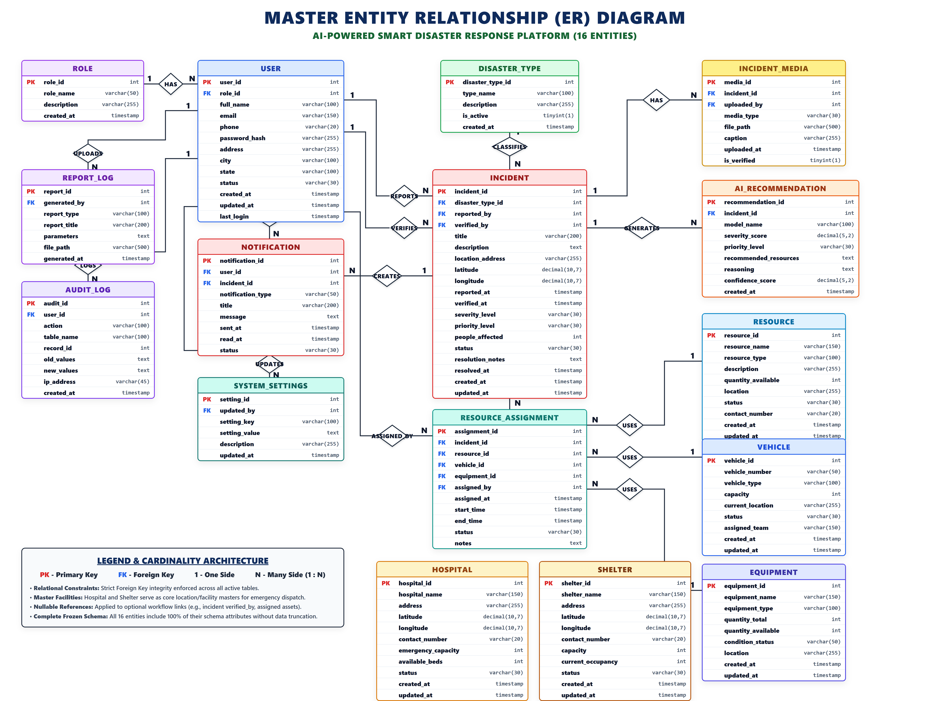
Figure 4.1: Entity Relationship Diagram of AI-Rescue

1. ROLE
Stores the roles available within the system.
Field | Description
role_id | Primary Key
role_name | Name of the role
description | Description of the role
created_at | Creation timestamp

2. USER
Stores registered users and their role information.
Field | Description
user_id | Primary Key
role_id | Foreign Key → ROLE
full_name | User's name
email | User email
phone | Contact number
password_hash | Encrypted/hashed password
address | User address
city | City
state | State
status | Account status
created_at | Creation timestamp
updated_at | Last update timestamp
last_login | Last login timestamp

3. DISASTER_TYPE
Stores the different types of disasters supported by the system.
Field | Description
disaster_type_id | Primary Key
type_name | Disaster type
description | Description
is_active | Active/inactive status
created_at | Creation timestamp

4. INCIDENT
Stores the main disaster incident information.
Field | Description
incident_id | Primary Key
disaster_type_id | Foreign Key → DISASTER_TYPE
reported_by | Foreign Key → USER
verified_by | Foreign Key → USER
title | Incident title
description | Incident description
location_address | Incident location
latitude | Geographic latitude
longitude | Geographic longitude
reported_at | Report timestamp
verified_at | Verification timestamp
severity_level | Severity classification
priority_level | Priority classification
people_affected | Number of affected people
status | Incident status
resolution_notes | Resolution information
resolved_at | Resolution timestamp
created_at | Creation timestamp
updated_at | Update timestamp

5. INCIDENT_MEDIA
Stores evidence associated with an incident.
Field | Description
media_id | Primary Key
incident_id | Foreign Key → INCIDENT
uploaded_by | Foreign Key → USER
media_type | Type of media
file_path | Stored file location
caption | Media description
uploaded_at | Upload timestamp
is_verified | Verification status

6. AI_RECOMMENDATION
Stores the output generated by the AI decision-support component.
Field | Description
recommendation_id | Primary Key
incident_id | Foreign Key → INCIDENT
model_name | AI model used
severity_score | AI-generated severity score
priority_level | Recommended priority
recommended_resources | Recommended resources
reasoning | Explanation of recommendation
confidence_score | AI confidence
created_at | Creation timestamp

7. RESOURCE
Stores general emergency resources.
Field | Description
resource_id | Primary Key
resource_name | Resource name
resource_type | Resource category
description | Description
quantity_available | Available quantity
location | Current location
status | Resource status
contact_number | Contact information
created_at | Creation timestamp
updated_at | Update timestamp

8. VEHICLE
Stores emergency-response vehicles.
Field | Description
vehicle_id | Primary Key
vehicle_number | Vehicle registration/identifier
vehicle_type | Vehicle category
capacity | Carrying/response capacity
current_location | Current location
status | Vehicle status
assigned_team | Assigned team
created_at | Creation timestamp
updated_at | Update timestamp

9. EQUIPMENT
Stores emergency equipment.
Field | Description
equipment_id | Primary Key
equipment_name | Equipment name
equipment_type | Equipment category
quantity_total | Total quantity
quantity_available | Available quantity
condition_status | Equipment condition
location | Current location
created_at | Creation timestamp
updated_at | Update timestamp

10. RESOURCE_ASSIGNMENT
Stores the assignment of resources to disaster-response activities.
Field | Description
assignment_id | Primary Key
incident_id | Foreign Key → INCIDENT
resource_id | Foreign Key → RESOURCE
vehicle_id | Foreign Key → VEHICLE
equipment_id | Foreign Key → EQUIPMENT
assigned_by | Foreign Key → USER
assigned_at | Assignment timestamp
start_time | Start of assignment
end_time | End of assignment
status | Assignment status
notes | Additional information

11. HOSPITAL
Stores emergency hospital information.
Field | Description
hospital_id | Primary Key
hospital_name | Hospital name
address | Hospital address
latitude | Geographic latitude
longitude | Geographic longitude
contact_number | Contact number
emergency_capacity | Emergency capacity
available_beds | Available beds
status | Hospital status
created_at | Creation timestamp
updated_at | Update timestamp

12. SHELTER
Stores emergency shelter information.
Field | Description
shelter_id | Primary Key
shelter_name | Shelter name
address | Shelter address
latitude | Geographic latitude
longitude | Geographic longitude
contact_number | Contact number
capacity | Total capacity
current_occupancy | Current occupants
status | Shelter status
created_at | Creation timestamp
updated_at | Update timestamp

13. NOTIFICATION
Stores notifications generated by the system.
Field | Description
notification_id | Primary Key
user_id | Foreign Key → USER
incident_id | Foreign Key → INCIDENT
notification_type | Notification category
title | Notification title
message | Notification message
sent_at | Sent timestamp
read_at | Read timestamp
status | Notification status

14. REPORT_LOG
Stores information about generated reports.
Field | Description
report_id | Primary Key
generated_by | Foreign Key → USER
report_type | Report category
report_title | Report title
parameters | Report parameters
file_path | Generated file location
generated_at | Generation timestamp

15. AUDIT_LOG
Stores records of important system activities.
Field | Description
audit_id | Primary Key
user_id | Foreign Key → USER
action | Action performed
table_name | Affected table
record_id | Affected record
old_values | Previous values
new_values | Updated values
ip_address | Source IP
created_at | Timestamp

16. SYSTEM_SETTINGS
Stores configurable system settings.
Field | Description
setting_id | Primary Key
updated_by | Foreign Key → USER
setting_key | Setting identifier
setting_value | Setting value
description | Setting description
updated_at | Update timestamp

2. Database Design
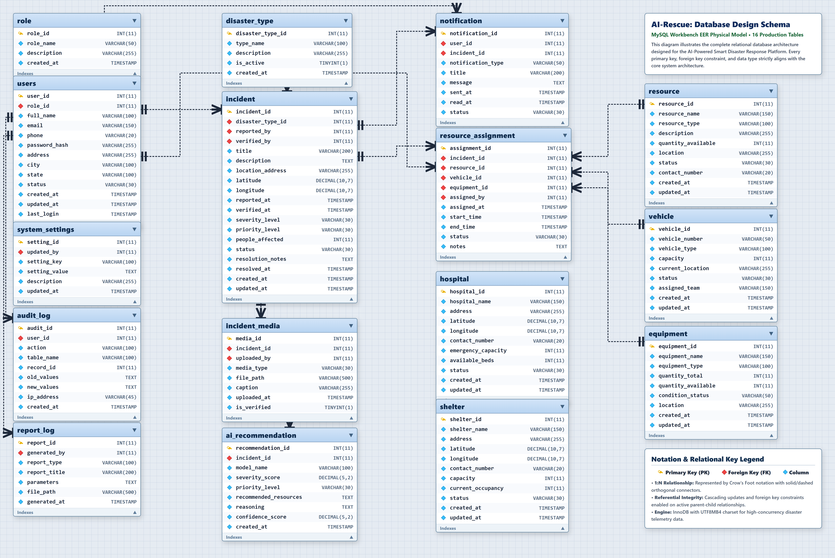
Figure 4.2: Database Design of AI-Rescue
The database design represents the relational structure of the AI-Rescue platform. The system uses 16 tables to store and manage operational data.
The database contains tables for user management, incidents, AI recommendations, resources, emergency facilities, notifications, reporting, auditing, and system configuration. Primary and foreign keys maintain relationships and data integrity.

4.2.2 Data Integrity and Constraints
Data integrity ensures that the information stored in the database remains accurate, consistent, and reliable.
The following constraints are considered in the database design.
Primary Key
Every table contains a unique primary key that identifies each record.
For example:
USER.user_id
INCIDENT.incident_id
RESOURCE.resource_id
HOSPITAL.hospital_id
Foreign Key
Foreign keys maintain relationships between related tables.
For example:
USER.role_id
↓
ROLE.role_id
and:
INCIDENT.disaster_type_id
↓
DISASTER_TYPE.disaster_type_id
NOT NULL
Important attributes should not be allowed to contain empty values.
For example, a user account should require essential information such as name, email, and password.
UNIQUE
Attributes such as email addresses can be restricted to unique values where required.
CHECK Constraints
Appropriate values can be restricted using validation rules.
For example:
people_affected >= 0
quantity_available >= 0
available_beds >= 0
current_occupancy >= 0
Referential Integrity
Foreign-key relationships prevent invalid references between related records.
Transaction Integrity
Database transactions can be used when multiple related operations must either complete successfully together or be rolled back.

4.3 Procedural Design
Procedural design describes the logical procedures followed by the system when processing different operations.
The major procedures include:
- User authentication.
- Incident reporting.
- Incident verification.
- AI analysis.
- Resource availability checking.
- Resource assignment.
- Incident response and status management.
- Notification processing.
- Report generation.

4.3.1 Logic Diagrams
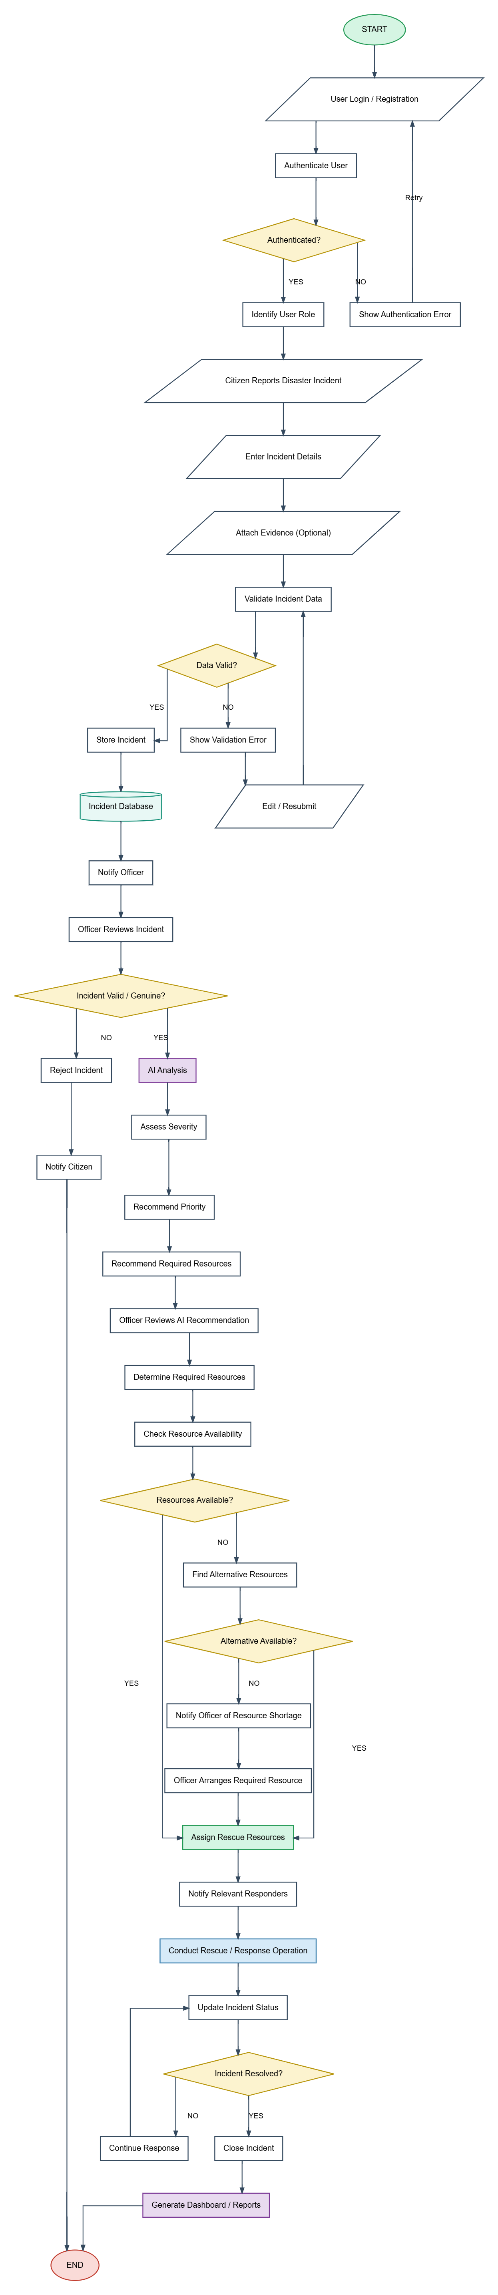
Figure 4.3: Overall System Flowchart
The overall system flowchart represents the complete operational workflow of the AI-Rescue platform, from incident reporting to incident resolution.
The workflow includes authentication, incident reporting, validation, officer verification, AI-assisted analysis, resource allocation, emergency response, status updates, and incident closure.

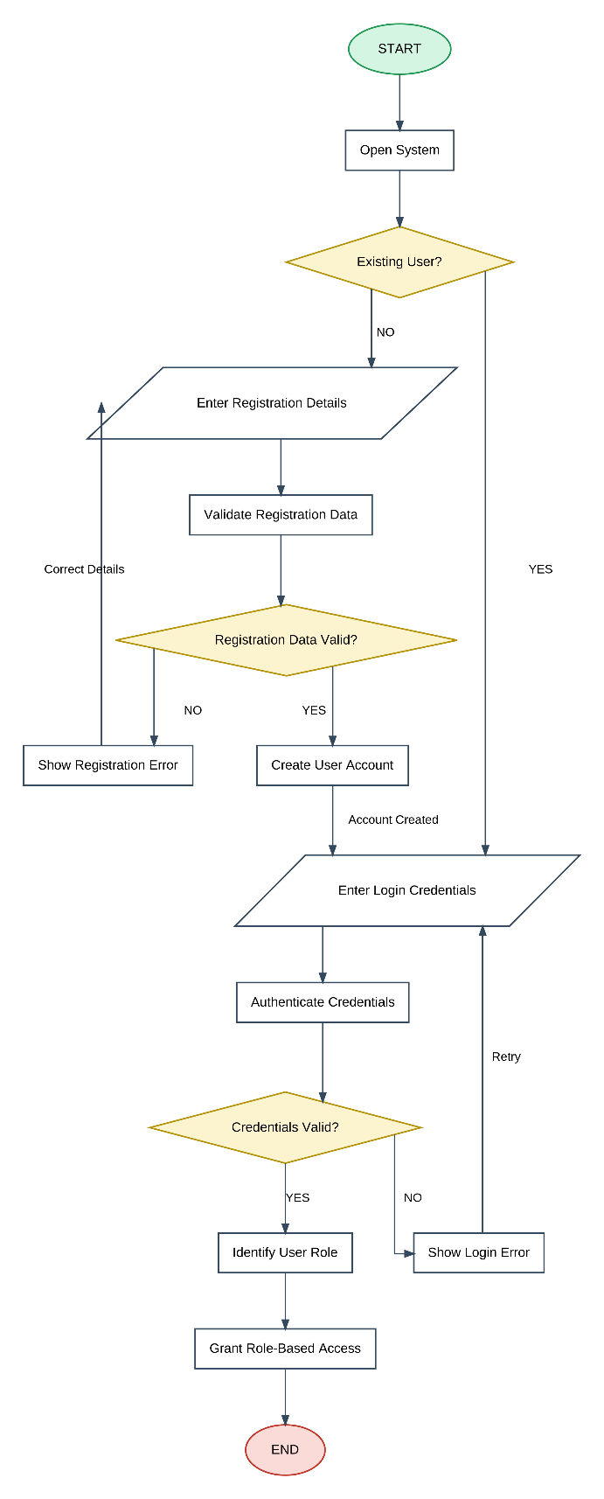
Figure 4.4: User Authentication Module Flowchart

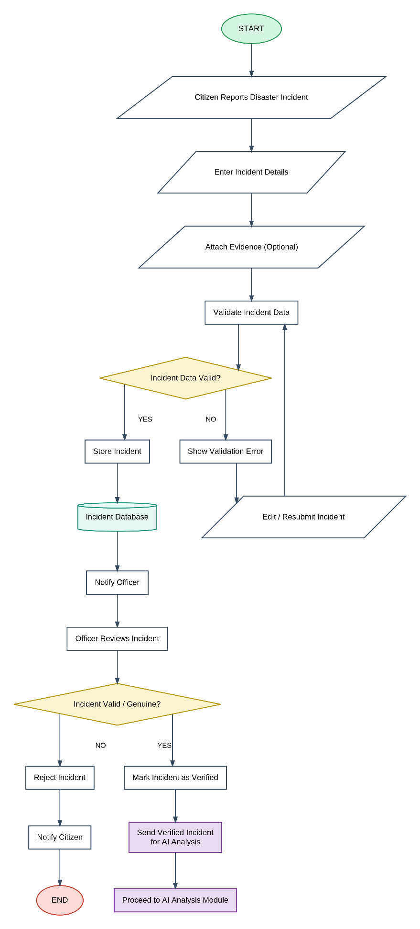
Figure 4.5: Incident Reporting Flowchart

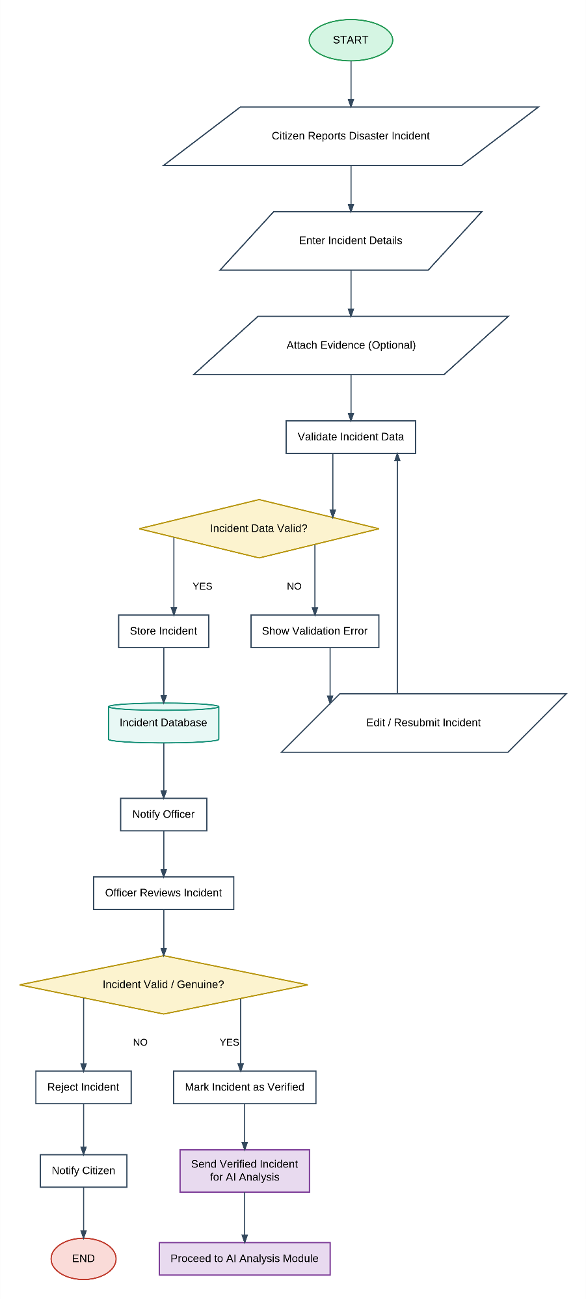
Figure 4.6: AI Analysis Flowchart

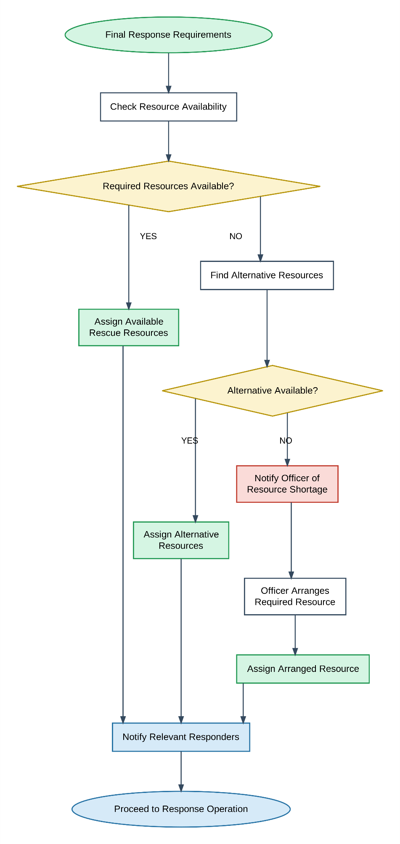

Figure 4.7: Resource Management and Assignment Module Flowchart

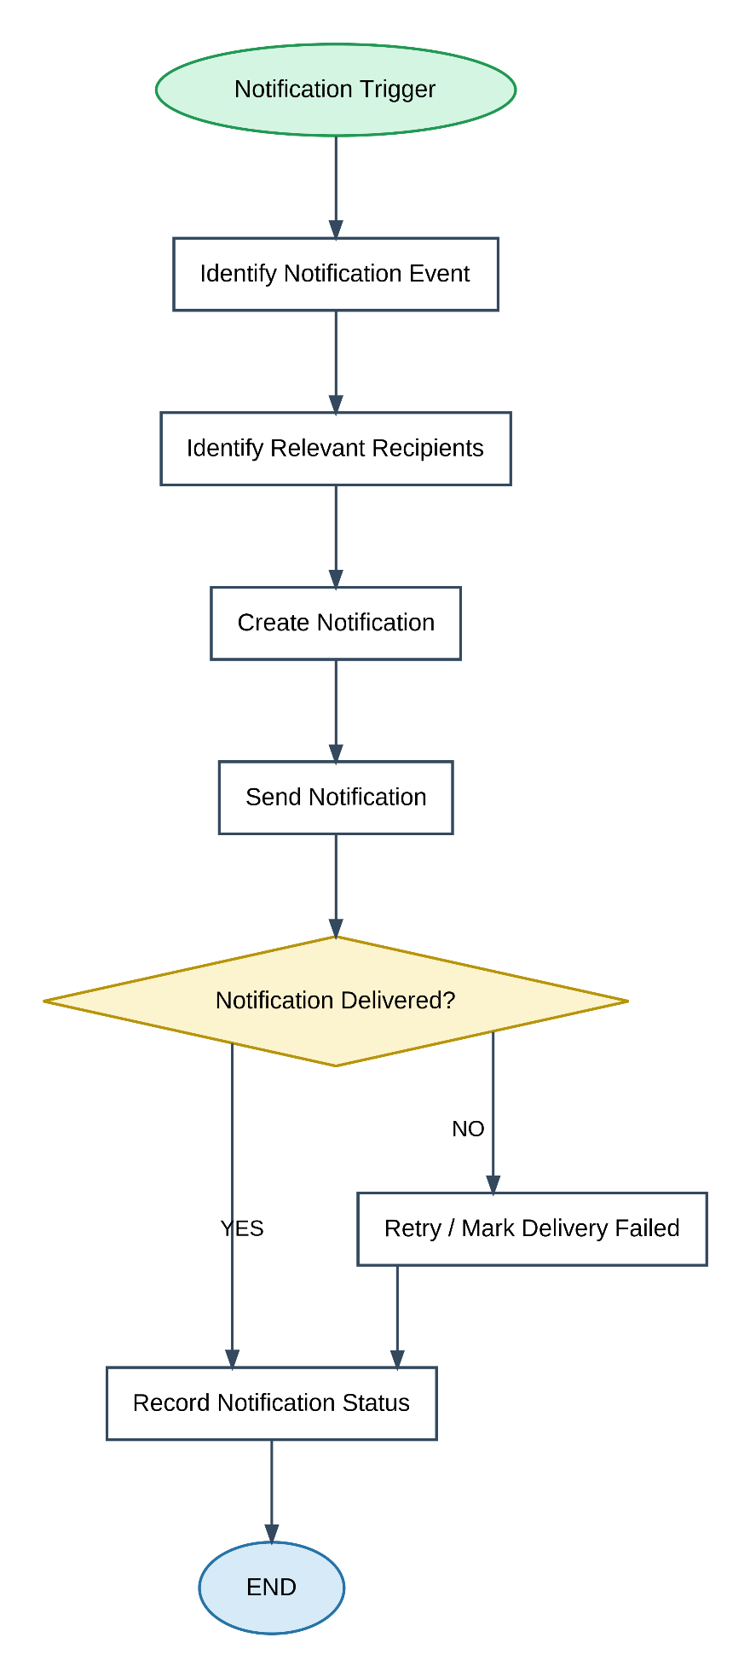
Figure 4.8: Notification Module Flowchart
The Sequence Diagram models the chronological procedural interaction between platform actors (Citizen, Response Officer, System Administrator) and core backend services (Authentication, Incident Service, AI Severity Engine, Resource Dispatcher, and Notification Engine) across the entire incident lifecycle.
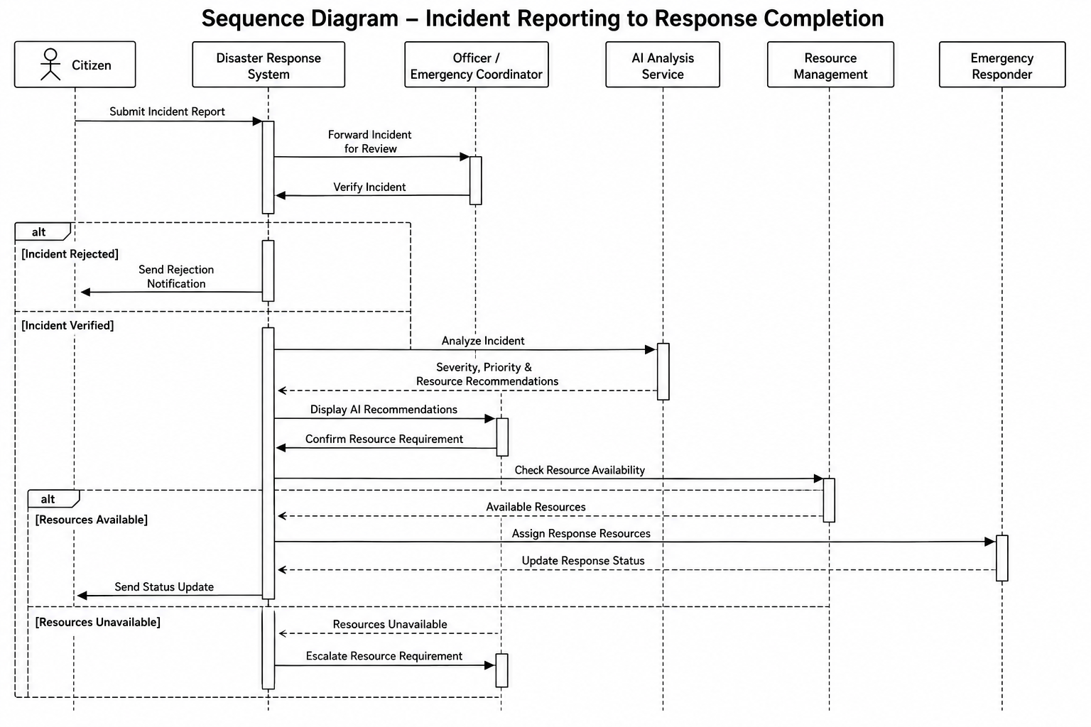
Figure 4.9: Sequence Diagram – Incident Reporting to Response Completion

4.3.2 Data Structures
The system uses several logical data structures during processing.
User Object
User
├── user_id
├── role_id
├── full_name
├── email
├── phone
└── status
Incident Object
Incident
├── incident_id
├── disaster_type_id
├── reported_by
├── location
├── severity
├── priority
├── people_affected
└── status
AI Recommendation Object
AI Recommendation
├── recommendation_id
├── incident_id
├── severity_score
├── priority_level
├── recommended_resources
└── confidence_score
Resource Assignment Object
Resource Assignment
├── assignment_id
├── incident_id
├── resource_id
├── vehicle_id
├── equipment_id
├── assigned_by
└── status
These structures represent the logical information handled by the application before or during database operations.

4.3.3 Algorithms Design
Algorithm 1: User Authentication
Step 1: Accept email and password.
Step 2: Validate the entered credentials.
Step 3: Search for the corresponding user account.
Step 4: Verify the password against the stored password hash.
Step 5: Check account status.
Step 6: If valid, create an authenticated session/token.
Step 7: Identify the user's role.
Step 8: Provide access according to the assigned role.
Step 9: Otherwise, display an authentication error.

Algorithm 2: Incident Verification
Step 1: Receive submitted incident.
Step 2: Display incident information to authorized officer.
Step 3: Officer reviews incident details and evidence.
Step 4: Determine whether the incident is genuine.
Step 5: If invalid:
Reject incident.
Update incident status.
Notify citizen.
Step 6: If valid:
Mark incident as verified.
Record verification details.
Send incident for AI analysis.

Algorithm 3: AI-Assisted Incident Analysis
Step 1: Receive verified incident data.
Step 2: Prepare relevant input attributes.
Step 3: Send the data to the AI service.
Step 4: AI processes the incident information.
Step 5: Calculate/estimate severity.
Step 6: Generate priority recommendation.
Step 7: Generate required-resource recommendation.
Step 8: Calculate confidence score.
Step 9: Return recommendation to the backend.
Step 10: Store the recommendation.
Step 11: Present the recommendation to the authorized officer.

Algorithm 4: Resource Availability and Assignment
Step 1: Receive verified incident and required resource information.
Step 2: Check available resources.
Step 3: Check vehicle availability.
Step 4: Check equipment availability.
Step 5: If suitable resources are available:
Select appropriate resources.
Create resource assignment.
Update resource status.
Notify relevant responders.
Step 6: If required resources are unavailable:
Identify possible alternatives.
Record the unmet requirement.
Escalate the requirement when necessary.
Step 7: Continue response planning.

4.4 User Interface Design
The user interface is designed to provide a simple and role-specific experience.
4.4.1 Login Page
The login interface provides:
- Email/username input.
- Password input.
- Login button.
- Registration option.
- Error messages.

4.4.2 Citizen Dashboard
The citizen dashboard can provide:
- Report disaster button.
- Submitted incidents.
- Incident status.
- Notifications.
- Profile information.

4.4.3 Officer Dashboard
The officer dashboard provides access to operational information such as:
- New incidents.
- Pending verification.
- Verified incidents.
- AI recommendations.
- Resource availability.
- Active responses.
- Notifications.
- Reports.

4.4.4 Administrator Dashboard
The administrator interface provides:
- User management.
- Role management.
- Resource management.
- System settings.
- Audit records.
- Reports.

4.4.5 Incident Reporting Interface
The incident reporting form can contain:
- Disaster type.
- Incident title.
- Description.
- Location.
- Geographic coordinates.
- People affected.
- Supporting evidence.
- Submit button.
The interface should clearly indicate mandatory and optional fields.

4.5 Security Issues
Because the platform handles user information and potentially sensitive disaster-response information, security is an important part of the system design.
4.5.1 Authentication
Users must authenticate before accessing protected functionality.
4.5.2 Password Security
Passwords should not be stored as plain text. Passwords should be stored using secure password hashing mechanisms.
4.5.3 Role-Based Access Control
Users should only access functions permitted by their roles.
For example:
Citizen
↓
Incident Reporting

Officer
↓
Incident Verification
AI Recommendation Review
Resource Assignment

Administrator
↓
System Management

4.5.4 Authorization
Authentication confirms who the user is, while authorization determines what the user is allowed to do.
4.5.5 Input Validation
User input should be validated to reduce invalid data and common security risks.
4.5.6 Secure Communication
Communication between clients and servers should use HTTPS in the deployed system.
4.5.7 Audit Logging
Important actions should be recorded so that system activities can be traced.
4.5.8 Database Security
Database credentials should be protected, and application users should receive only the permissions required for their operations.

4.6 Test Cases Design
Testing is required to verify that the system behaves according to its functional requirements.
The following test cases represent the major V1 functionality.
TC ID | Test Case | Input/Condition | Expected Result
TC-01 | User Registration | Valid registration details | Account created successfully
TC-02 | User Registration | Duplicate email | Registration rejected
TC-03 | Login | Valid credentials | User authenticated
TC-04 | Login | Invalid password | Error displayed
TC-05 | Role Access | Citizen accesses officer function | Access denied
TC-06 | Incident Reporting | Valid incident details | Incident submitted
TC-07 | Incident Validation | Missing mandatory field | Validation error
TC-08 | Incident Verification | Officer marks incident valid | Incident becomes verified
TC-09 | Incident Verification | Officer rejects incident | Incident rejected and notification generated
TC-10 | AI Analysis | Verified incident | AI recommendation generated
TC-11 | AI Analysis | Unverified incident | AI analysis not initiated
TC-12 | Resource Availability | Available resources | Resources can be assigned
TC-13 | Resource Availability | No suitable resource | Alternative/escalation process initiated
TC-14 | Resource Assignment | Valid assignment | Assignment stored and resource status updated
TC-15 | Notification | Operational event occurs | Relevant notification generated
TC-16 | Incident Resolution | Incident resolved | Incident closed
TC-17 | Report Generation | Valid report request | Report generated
TC-18 | Audit Logging | Important system action | Audit record created
TC-19 | Hospital Information | Update hospital capacity | Updated information stored
TC-20 | Shelter Information | Update shelter occupancy | Updated information stored

CHAPTER 4 SUMMARY
The system design defines the architecture, modules, database structure, processing logic, algorithms, interface design, security considerations, and testing approach of the AI-Rescue platform.

